Playarr Improvements and bugs
Playarr is a vibecoded project, so is likely to contain a significant amount of bugs, duplicates in code and issues. At a basic level, the app uses ytdlp to download music videos, and then with a combination of scrapers and AI API oversight, it creates descriptions and organises artwork for playback in a stylised manner. It has additional features based around metadata and video editing to improve the video quality.
A critical long-term feature is integration with themusicvideodb.org. The app collects details about how information is retrieved, edited and supplied. When information is pushed to themusicvideodb, this will be used to create trust and provenance.

General Issues
An audit of the code for consistency needs to be completed. UI/UX consistency is a significant issue.
All settings where possible, should be stored at a database level so that the display is consistent across multiple devices.
Most navigation panes are missing the ability to switch between grid and list view.
An audit for renaming files when they’re reclassified, their side car and associated artwork renaming, and how this is handled by the database needs to be conducted. This should include what happens if an action triggering a rename is called while the file is accessed, and how this can be queued up for later.
Side cars are the most significant component to the app. There is information for kodi scraping, but at a more detailed level, it should be possible to fully recreate a database from side cars, including the full provenance pathways. It should be possible to see if AI was run, or wasn’t as an example. This means that if the user moves a music library to a different location, then runs the import features, the entire library should be rebuilt as-is, allowing for the status of video edits, redownloads, links to archives etc to be entirely rebuilt. This should include unique IDs, so even if the archive is moved to a different location, it can be correctly linked to its original source when scanned back in. The side car and database need to be audited along the entire pathway to ensure they’re meeting this compliance requirement.

Playback Mode
An audit of playback modes for compatibility and overhead needs to be completed.
PC
When using playback mode on the pc, switching the video to full then leaving full screen causes the video playback to disappear (audio continues). If the user then navigates away from the player, and back to the player, the video resumes. This isn’t an issue with theatre mode.
During playback, when moving the mouse the queue is restored. The info box about the video should also be restored. This change should cover other playback modes.
TV Mode
There is an undiagnosed bug with TV mode where a track may complete, or prematurely complete, then resume from the start.
The TV Mode intro can be improved. It currently has a simplified year filter, but otherwise plays based on the settings in the app. TV mode has proven to be relatively easy to navigate, so more appropriate navigation controls can be introduced. To improve this, the basic content filters should be visible on the start panel as well as the party mode playlist choices. These should be styled to be visually consistent with the tv mode panel, and easy to click and navigate in that context.
This will make the playlist partially independent to the base app since it will have some general restrictions available. The exclusions list will still apply.
This change allows the user to easily use a pre-made or general play list but customise it to the audience (eg excluding adult videos).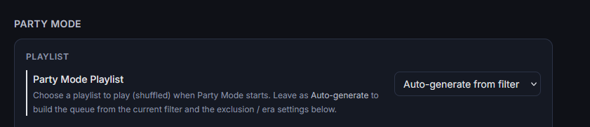
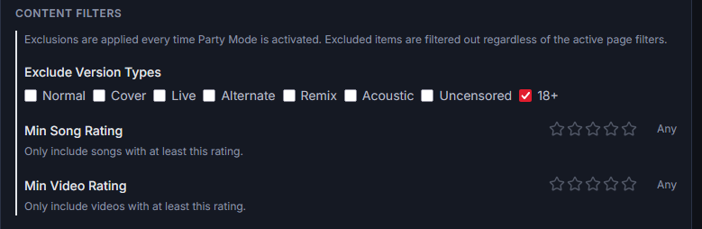
The playback controls for tv mode need to be improved and simplified.
Currently moving the controller restores the queue view as intended, but it doesn’t restore any controls. The existing track control bar isn’t suitable for the application in TV mode. It should consist of three large buttons, previous track, random track, next track, below the music video info box. These should be large, stylised and obvious with the intention to be used with clunky navigation controls like a TV remote. This should be carried over to cast mode.
Kodi Add-on This can be removed.
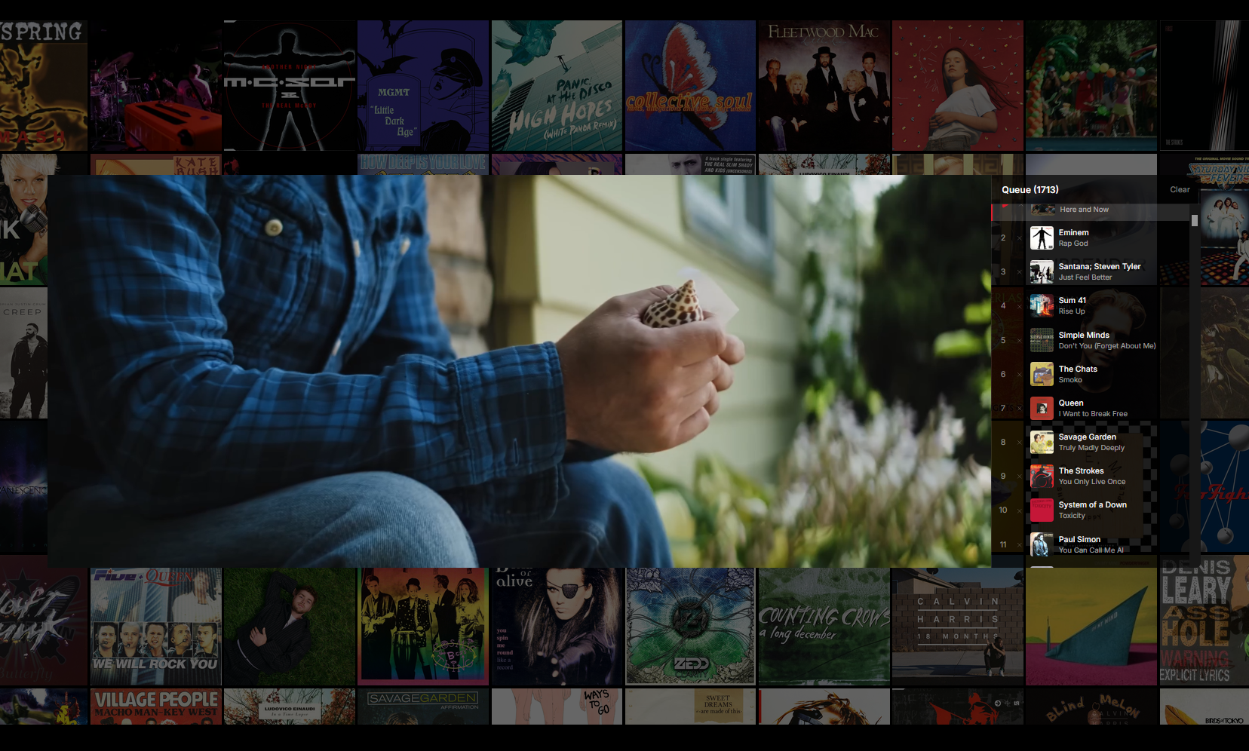
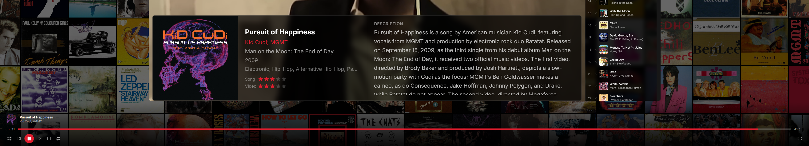

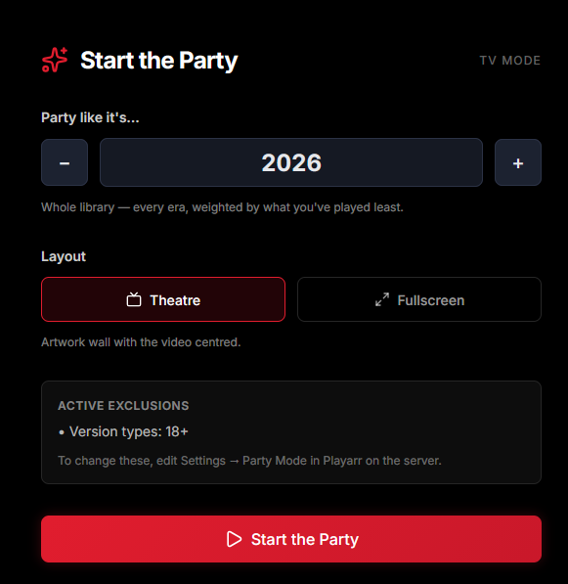

Library side tab
The library side tab is strong, but it has issues for UI/UX which are most obvious in the list view.
The headers artist/title should be two separate columns. Year/quality are misaligned to their columns.
Clicking the headers should sort the display by that selection. Eg, selecting year should sort by year, selecting it again should invert the sort order.
The AI column appears to have no link to the AI drop down filter, selecting the type of AI enrichment doesn’t seem to link to statuses like AI ½. This highlights a more significant and broader app problem, there is no definition of what the AI statuses mean and why the user would want to filter them.
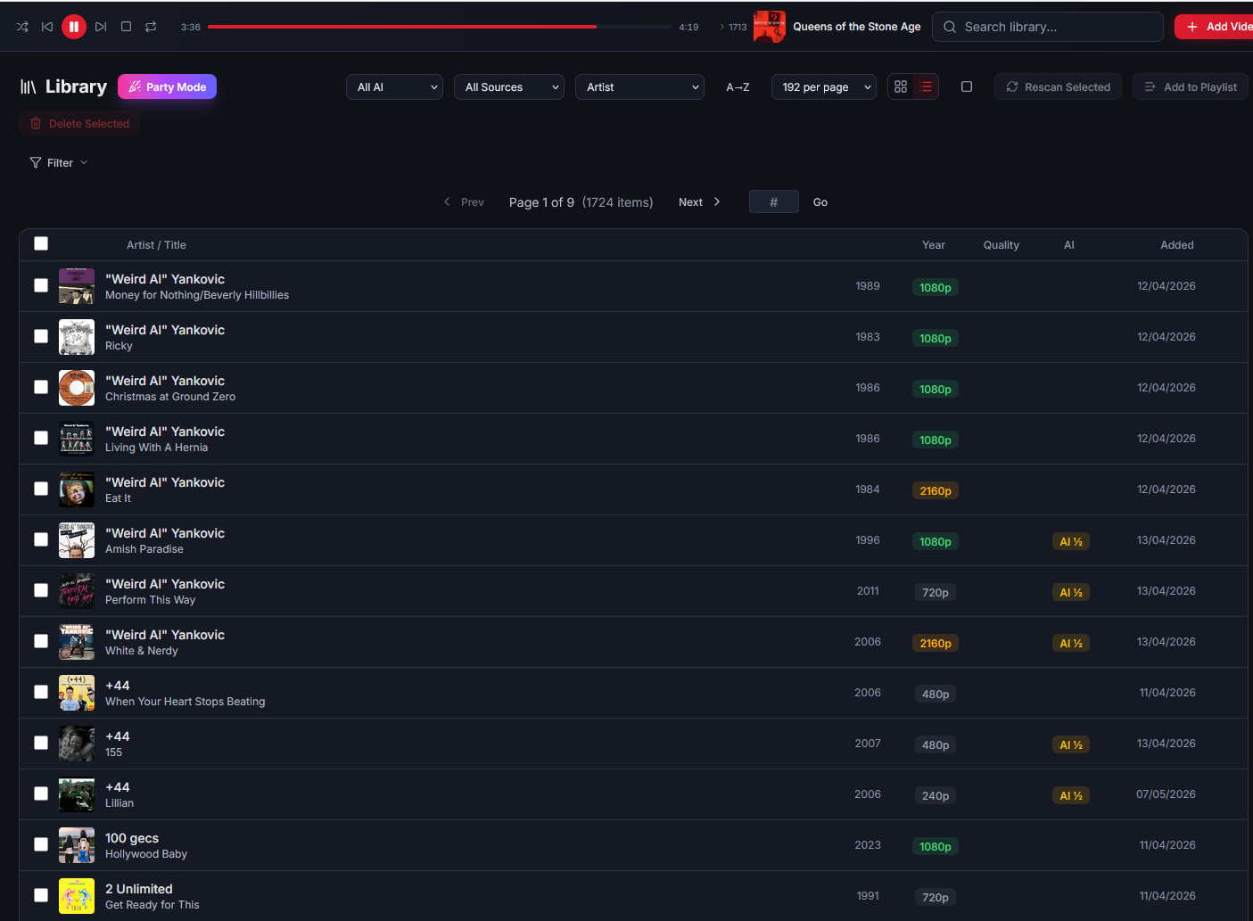
The header bar filters, and the expandable filter box appear to have significant overlap. The header bar filters and the expandable filter should be integrated into a single function in a non-collapsible tile below the header bar, removing all redundancy. This should carry over to all navigation panes (artist/albums/etc)
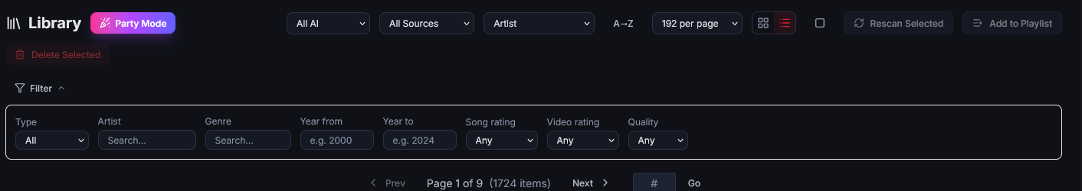
Playlists
When a playlist is selected and opened, the edit playlist function isn’t fully developed. The panel should resemble a simplified library panel with columns/filters for sorting by artist, title, album, year. There should be a check box to the left of a track to select for bulk actions.
Bulk actions include:
-Removing from the playlist
-When a sort by action is applied, it only applies to the bulk selected items.
Next to the apply button should be an ‘undo changes’. Apply should be renamed to ‘save changes’.
The user should be able to click and drag music tiles around on the play list so that they can change the order quickly.
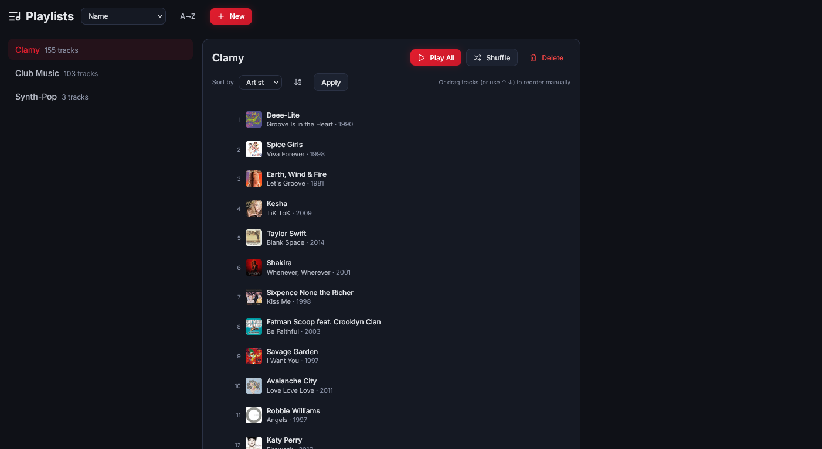
New videos
This feature is powerful, but has completeness issues.
Pressing add, redirects the user to the queue rather than just clearing the item from the suggestions and adding it to the queue silently, leaving the user on the page.
There are occasions where the suggested tiles are different sizes, causing navigation issues.
When a suggested tile is cleared it should be replaced with a new tile, so that the space is never empty.
The refresh button should be renamed ‘fresh list’, and should totally renew the list.
The fields often aren’t filled, in the sample screen show, the songs you might like is almost entirely empty.
The recommended by artist category tends to be saturated by a single artist instead of being a genuine, weighted recommendation.
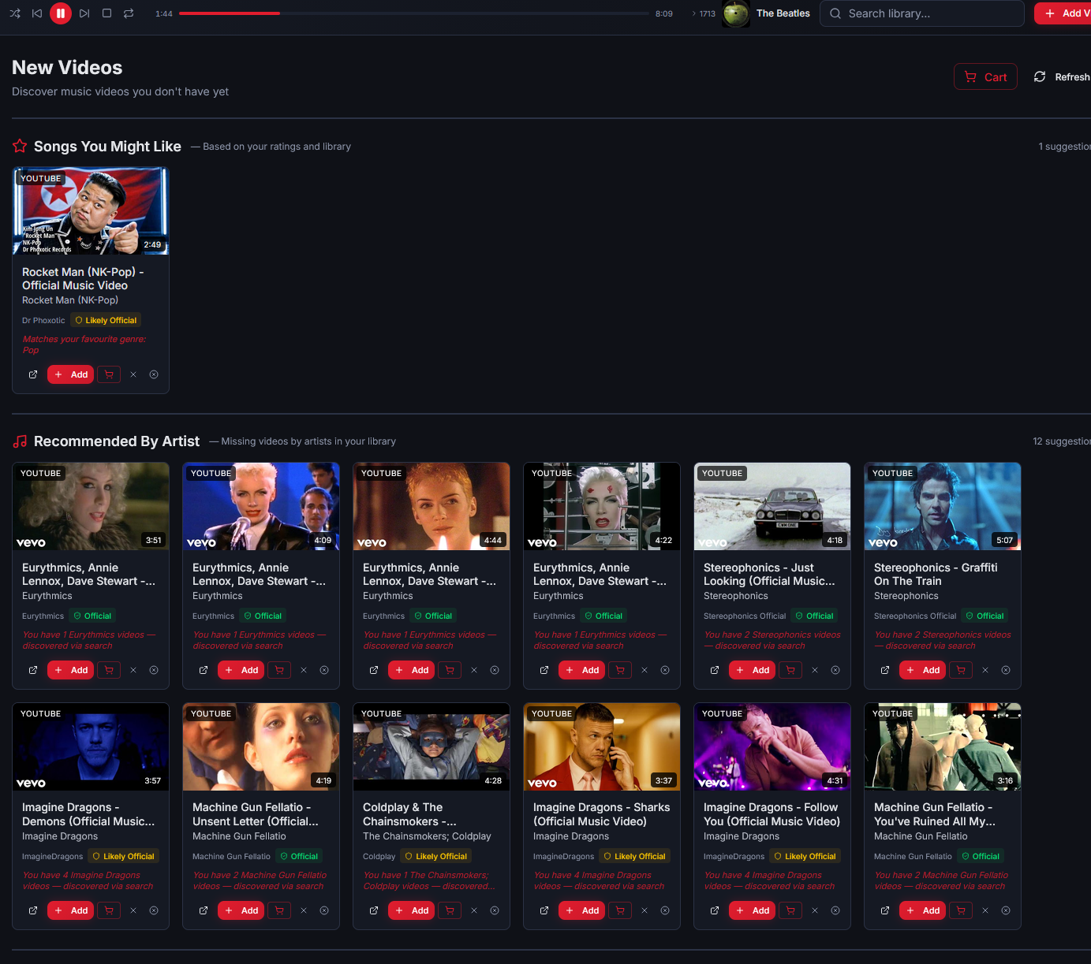
Queue
This is a powerful tool, but it needs significant improvements to UX. UI/UX consistency between queue, review, video editor, metadata and archive needs to be investigated and applied.
An issue that has plagued the queue, and any database edits since the early version of the app have been race conditions. There are many places where writes to the database can be initiated concurrently, such as changing details in an individual track while a download is active in the queue. Serialising actions fully forces the system to become dysfunctional slow, so semi-serialisation exists, where items that can occur in parallel do (such as downloading), but writes to the database are serialised (such as metadata). This has still caused performance issues, where the user tries to initiate an action such as queuing a new download through new downloads and the UI will hang until the writes have cleared. A deep audit of every possible write action in the app needs to be undertaken to identify issues with race conditions, and ensure that there are none remaining, and that all actions that can occur while the database is locked, don’t lock the user experience but are smoothly queued for their write turn.
The database architecture is simple, and is a 1:1 copy of all nfo sidecars – information is a mirror. It may be possible to write sidecars to a temporary location where race conditions aren’t an issue, and then have the actual database periodically scrape the temp location for additions/modifications/removals/etc to implement. You need to do a deep dive into what is the best solution, specifically established long-term proven solutions for the operation of this app to permanently solve this problem.
Featured prominently on the queue page should be the yt-dlp version and update the version button.
The top row contains some filter pills, active, fownloading, complete, failed etc. When a pill is selected, there are additional filter rows, one containing all downloads imports editor scraper clear, and then below that, all types, downloads, imports editor, scraper with a simple date filter.
This is too much duplication and causes issues for the user. The page layout needs to be simplified with the pills instead being displayed as page tabs, and the filters on those pills being simplified to sub tabs, with the redundant filters removed.
The pills/top level tab should be Active, Complete, Failed, Cancelled, Skipped.
When a tab, like active is selected, the user has sub tabs to filter between All/Downloads/Imports/Video Editor/Scraper.
All – All jobs that meet the top level tab
Downloads – Any download job (redownload, or a job that was started from a download link)
Imports-Any job that is being imported into the library through an import from disk pathway.
Video Editor-Any job that is sent to the queue from the video editor
Scraper-Any job that is sent to the queue from the scraper. This is distinct to the download calling the scraper. A scraper action would be the user going to a specific video and calling a scrape through any of the pathways, such as AI/wiki.

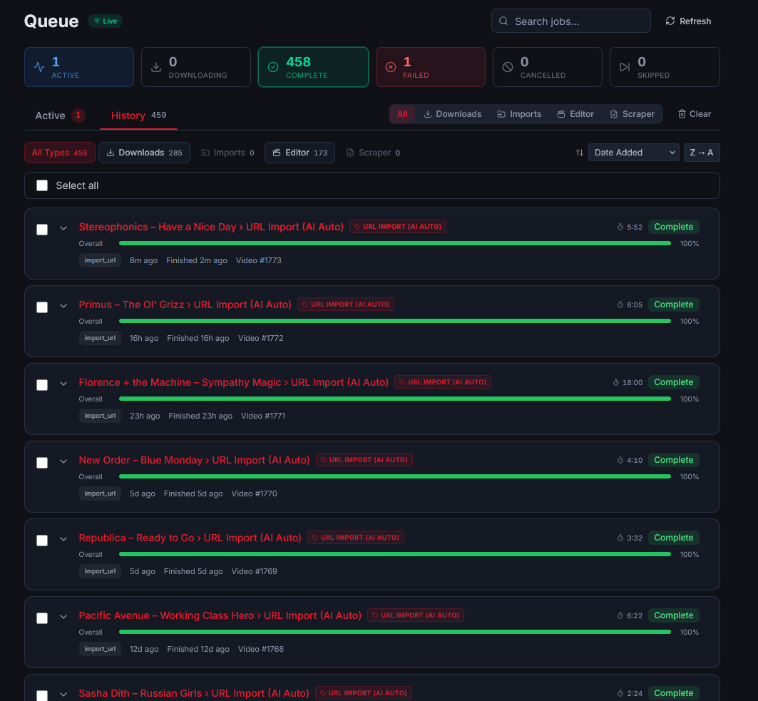
Review Queue
One of the most important features of the app, this allows the user to de-duplicate the library but the implementation is poor and difficult to navigate. As discussed already, it needs to be visually consistent with the queue tab, which it isn’t.
Fundamentally it serves the following functions:
-De-duplication for tracks that have the same or different quality.
-De-duplication for tracks that are the same but are different versions of a video, or alternate versions like live recordings.
-Flagging tracks that have poor certainty during the import process. This can include uncertainty that a track is a specific version, or any part of the selected scraping process failed to fire. For example, the full sweet was selected but the AI never returned any values and timed out.
-Flagging tracks that experienced issues during volume normalisation, or tracks in the library that have volume normalisation that doesn’t match the desired settings.
-Flagging tracks that exist in the library but aren’t included in the library. This will most likely occur with videos that are named slightly different than an existing track, and are in the same folder.
A deep audit of the current feature set needs to be completed as well as additional improvements to make these goals more functional.
The layout of the duplicate group tiles need to be improved. Half the tile should be a mini video player, allowing the user to play suspected duplicate tracks in place to see if they’re the same. A simple provenance for the suspected duplicate should be included (similar title, same title, same audio fingerprint etc). Added date should be a visible point of comparison.
The drop-down box for reclassify is unusually sized and spills off the screen. Making it difficult for the user to read.
In cases where multiple duplicates are detected, they should flag as separate bi-directional cases. For example, if three videos are flagged, that means V1-V2 V1-V3 and V2-V3 should all show up as separate comparisons. If V1 is solved in a way that clears another suspected conflict (for example, being deleted), the duplicate tiles it also affected should clear.
The desired workflow for duplicate management is the user chooses to reclassify one or both videos, delete both or one video, and then chooses to commit the actions. They can also dismiss the action altogether.

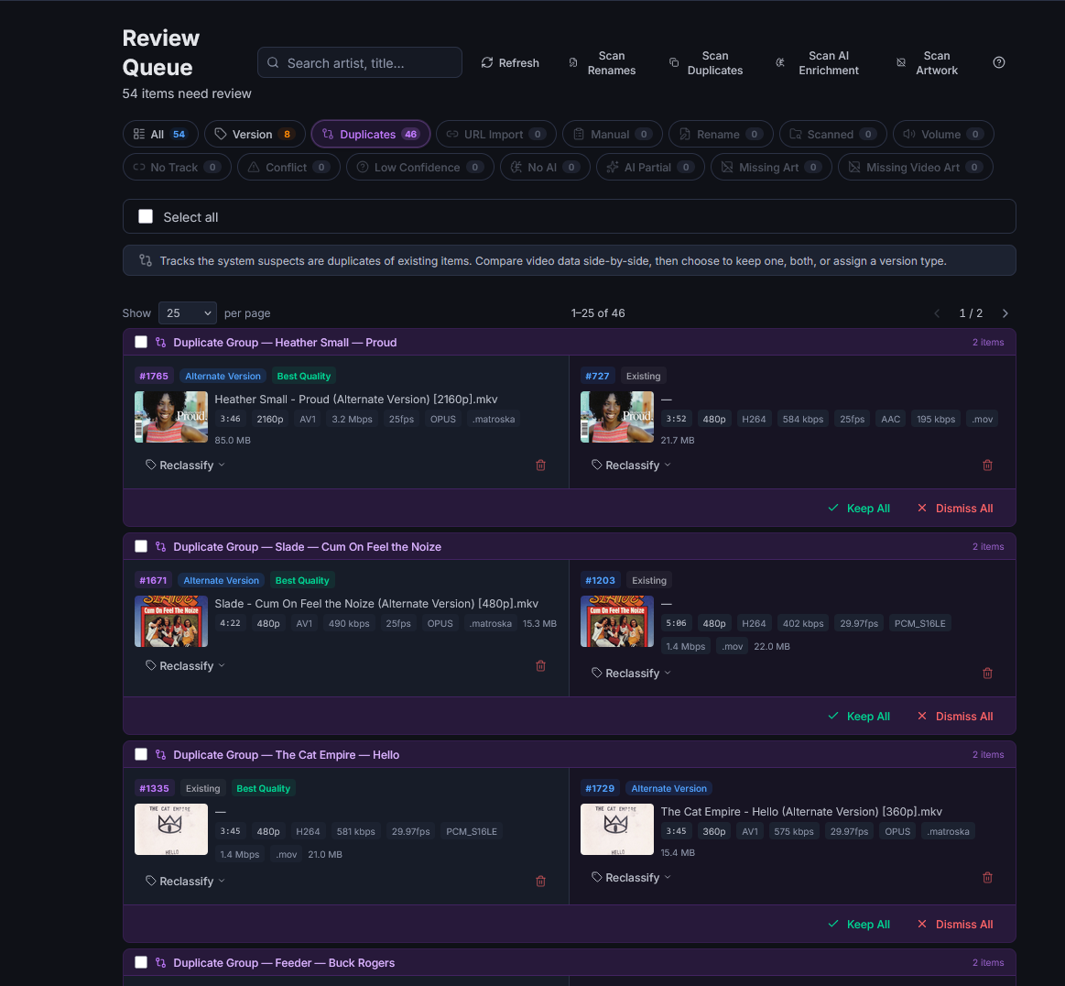
Version review for tracks that aren’t flagged as duplicates needs improvement similar to the duplicate management, with the mini-playable video being available within the tile.
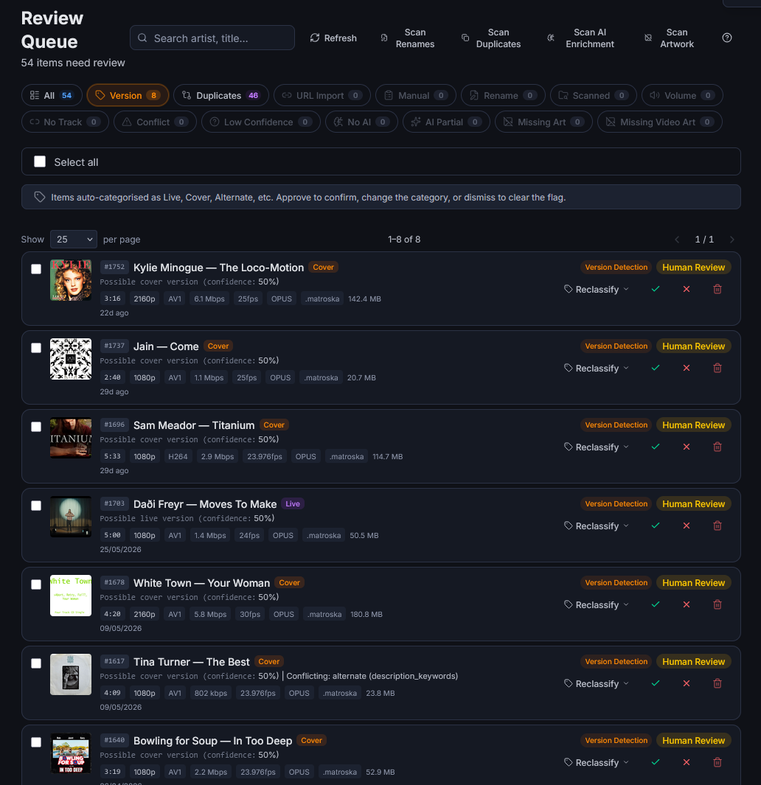
With this context and the changes, the entire functionality of the review tab needs to be reviewed. Unnecessary, or redundant features should be cleaned up and removed.
Video Editor
This is an extremely powerful feature designed to correct poorly letterboxed videos, to correct faulty aspect ratios, and to trim additional footage that shouldn’t be on the clip.

The default encode settings often create lower resolution, blocky videos compared to the source material, particularly if the source material was 1080p+. The default encode settings should be set with visual fidelity to be practically identical to the source video. This should include maintaining the original frame rate. This requirement should also carry over to audio encoding when that is required.
The crop detection has been improved, but it has issues. Typically the most noticeable is that on letterboxed videos with high resolution it often detects a false positive for horizontal cropping of a few pixels. It still generates large false positives for other videos.
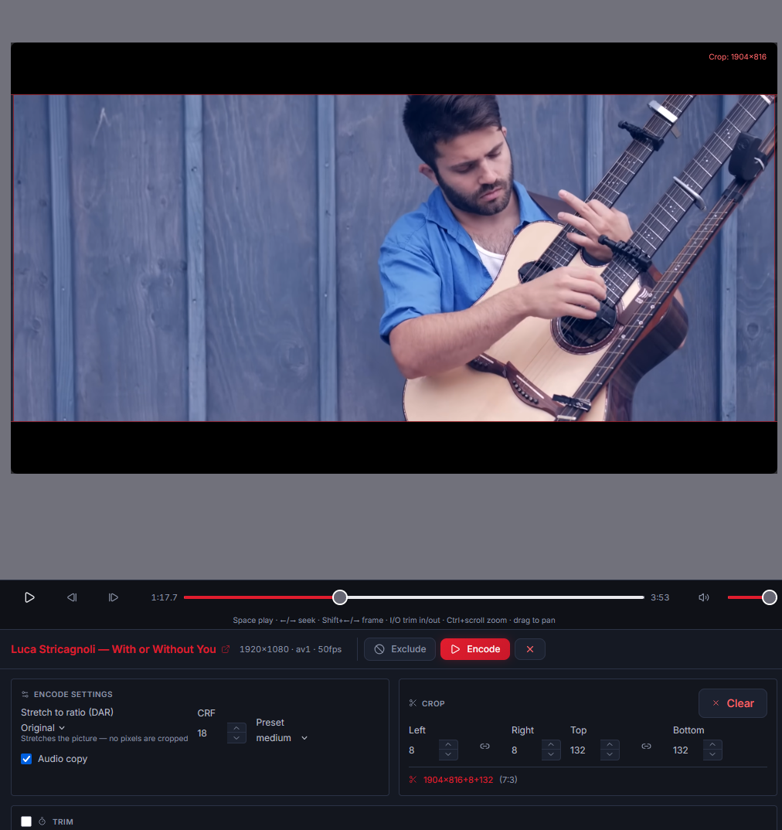
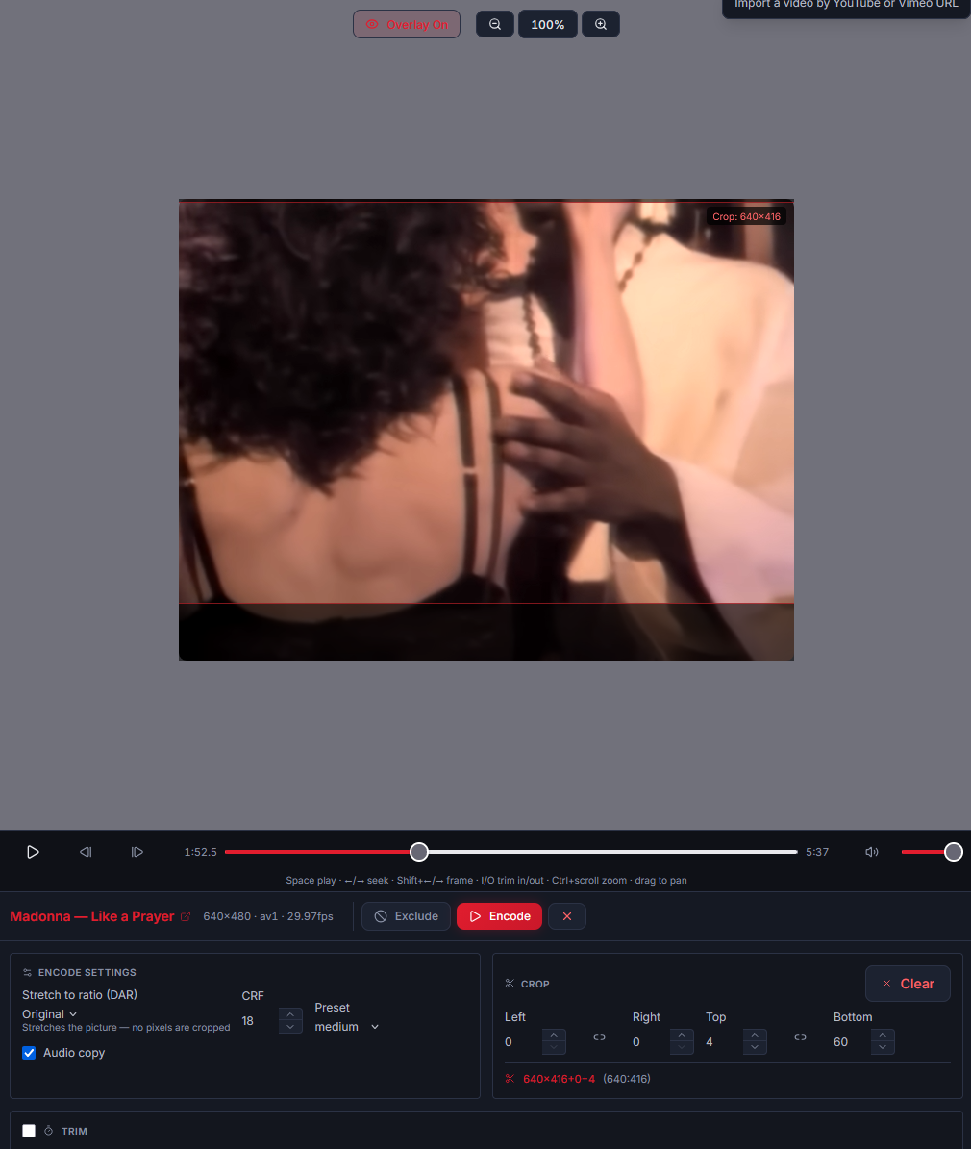
Metadata Manager
A key feature of Playarr is an enjoyable visual aesthetic, this comes down to a healthy metadata library.
The MBID coverage flags artist name conflicts, but when viewed in the artist consolidation feature, there are no artists available.
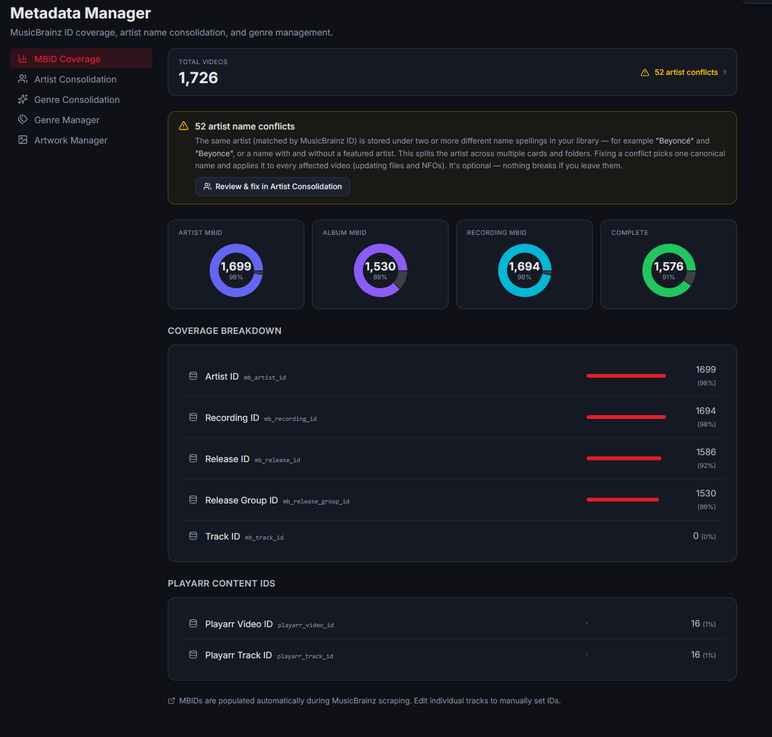
Artist Consolidation and genre consolidation are functionally identical in terms of what they’re out to achieve, so there is significant overlap between how they should display information.
Artist consolidation should have a column-based layout:
MBID-Mask Name-Target Names. Each column can have names added or removed.
For example, an MBID exists with two target names that aren’t identical, so it appears in the artist consolidation list with an MBID and both names as target names and mask name is blank. The user can drag one of the names into the mask name, manually enter a name, or search for a name, which then becomes the name visible in the library masking the target names. If in this process, a target/mask name is chosen with a different MBID then there will be two MBIDs in the MBID column. Removing the names attached to the MBID will clear that MBID, and vice a versa, removing an MBID from the column will clear its attached names from the other columns.
In cases where artists don’t have MBIDs, and the similarity between artists is flagged by regex similarities, the user will have the same capabilities. They can add artists, assign one as a mask or target, add other names for masks or targets.
Being able to manually create new consolidations and delete existing consolidations is a critical feature.
This behaviour should be the same for genre consolidation, but it will only need two columns since genre mbids don’t exist. The blacklist/whitelist toggle can remain on the genre consolidation page.

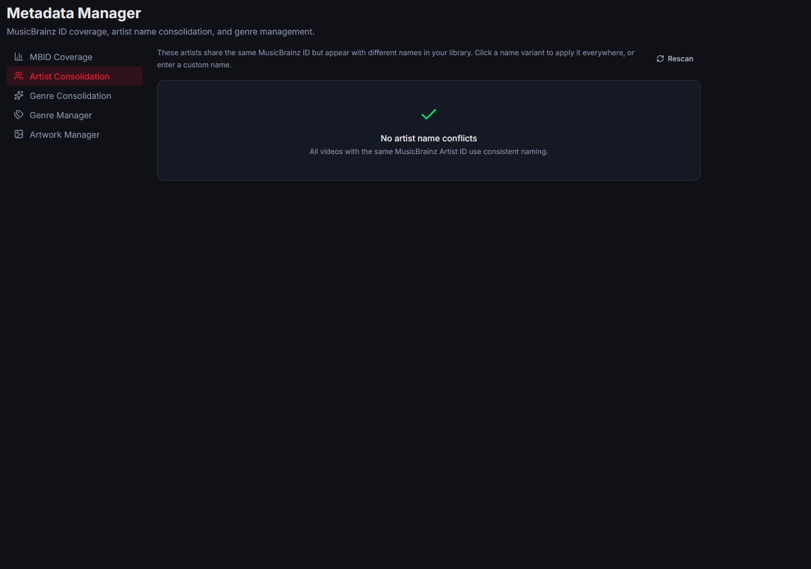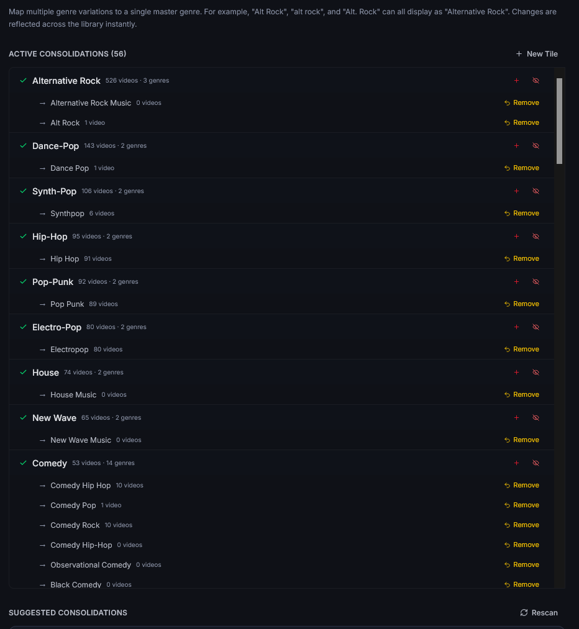
Genre Manager
The genre manager should carry over masks from the genre consolidation page. So if a consolidation is made, only the mask should be visible in the manager.
Genres with zero videos shouldn’t ‘exist’, since they affect nothing for navigation and searching, therefore they shouldn’t be in the list of genres to hide.
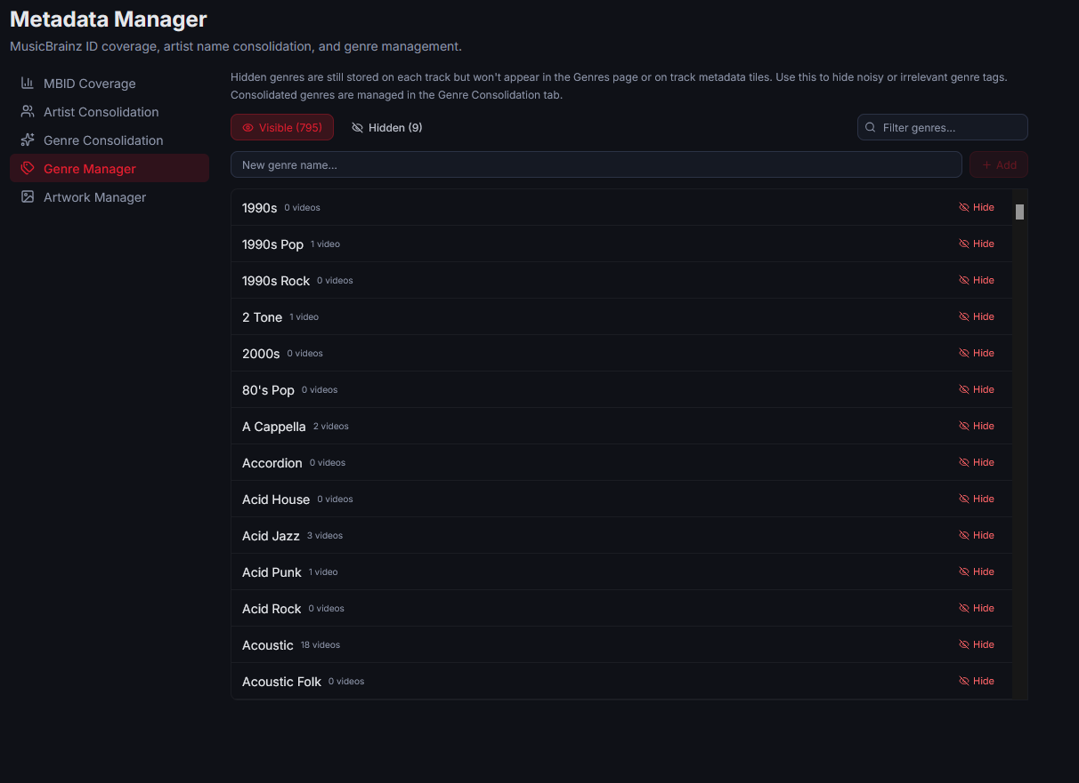
Archive
This is a powerful tool for restoring edited or redownloaded videos. It works well with all required functionality, but the UI should be brought in line with the changes to Queue.
Scraper Tester
Scraping is a critically important feature; the app fundamentally doesn’t work without the scraping tools. Scraper testers functionality is about testing and error reporting all the different methods that videos can be imported then scraped. Specifically, it is meant to show every step in the scraping process and the data sent/received to assist with troubleshooting.
At a broader level, the apps importing/downloading pathways need to be audited to ensure they are converging. If wiki only is used, is that the action taking place at every step? Does providing a link correctly target the wiki scraper? If AI auto is used, is it proof-reading scraped data?
Settings
The functionality of most settings is strong, but the layout is poor.
Through most of my apps I use a three-column layout where practical.
Field Name-Field entry-Field description.
This should be applied here.
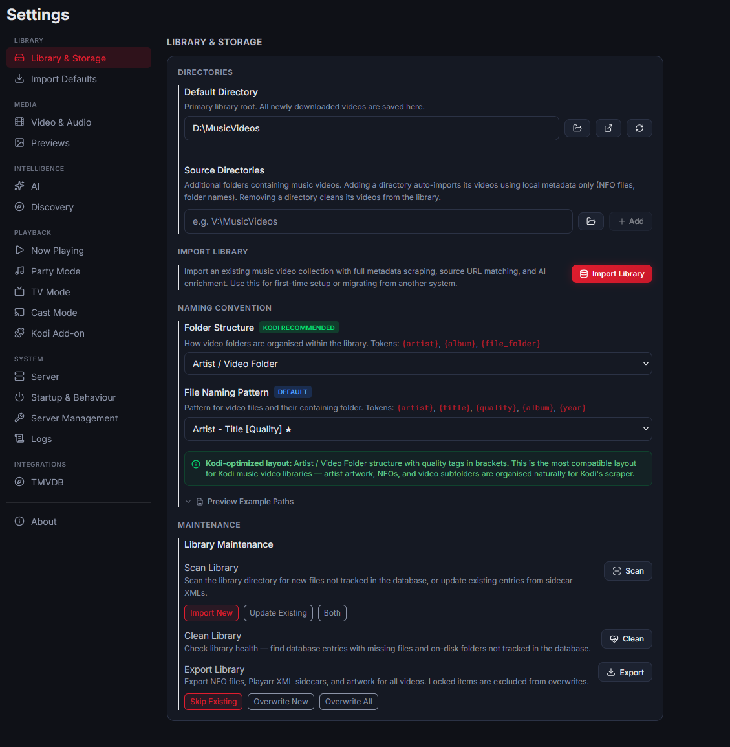

All settings sub tabs, their actions and relationships to the wider application need to be audited to ensure they’re actually connected. Grouping, explanations and organisation of the settings sub tabs and the category breaks needs to be audited.

